Bài tập hướng dẫn thiết lập webmail với Squirrelmail for Centos 6.7
Mô hình mạng:
Máy Centos67 ====>
/etc/sysconfig/network-scripts/ifcfg-eth0
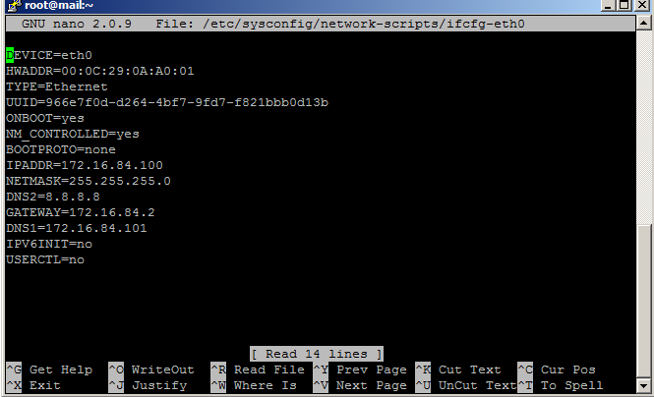
/etc/sysconfig/network
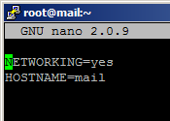
/etc/hosts
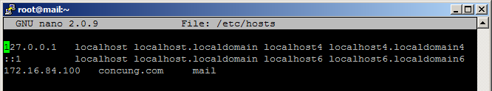
Set IP:
IP address : 172.16.84.100/24
Default gateway : 172.16.84.2
DNS1: 172.16.84.101
DNS2: 8.8.8.8
Máy Windows Server 2003/2008/2012
IP address : 172.16.84.101/24
Default gateway : 172.16.84.2
DNS1: 172.16.84.101
Thiết lập dịch vụ DNS sau :
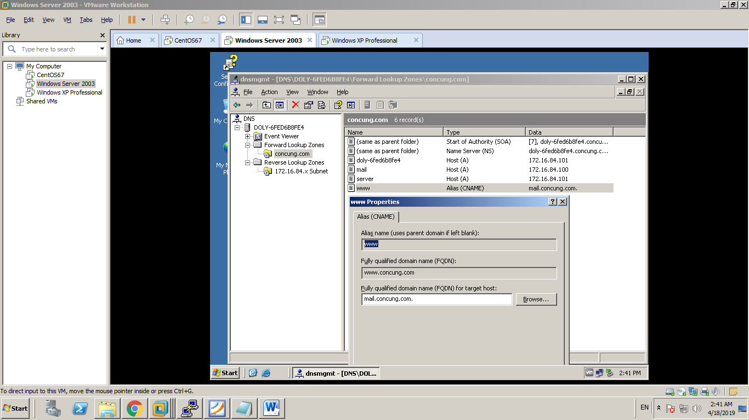
Máy Windows XP professional
IP address : 172.16.84.102/24
Default gateway : 172.16.84.2
DNS1: 172.16.84.101

BƯỚC 1 : CÀI ĐẶT VÀ CẤU HÌNH POSTFIX
#yum update (có thể bỏ qua)
#yum install postfix
/etc/postfix/main.cf
myhostname = mail.concung.com
mydomain = concung.com
myorigin = $mydomain
inet_interfaces = all
mynetwork = 172.16.84.0/24 127.0.0.0/8
home_mailbox = Maildir/
#service postfix restart
#chkconfig –level 35 postfix on
BƯỚC 2: CÀI ĐẶT VÀ CẤU HÌNH DOVECOT
#yum install dovecot
/etc/dovecot/conf.d/10-mail.conf
*****************************************
mail_location = maildir:~/Maildir
*****************************************
/etc/dovecot/conf.d/20-pop3.conf
*****************************************
pop3_uidl_format = %08Xu%08Xv
pop3_client_workarounds = outlook-no-nuls oe-ns-eoh
*****************************************
/etc/dovecot/dovecot.conf
*******************************************
protocols = imap pop3 lmtp
disable_plaintext_auth=no
*******************************************
#service dovecot restart
#chkconfig --level 35 dovecot on

BƯỚC 3: CÀI ĐẶT VÀ CẤU HÌNH WEBMAIL SSL (https://)
#yum install mod_ssl
#cd /etc/pki/tls/certs
#make server.key ===>Nhap password is : p@ssw0rd
#openssl rsa -in server.key -out server.key ===>nhap password is : p@ssw0rd
#root@mail certs# make server.csr
******************************************************************
Enter password is : p@ssw0rd
Country Name (2 letter code): vn
State or Provice Name (Full Name): hcmcity
Locality Name (eg, city) : hcmcity
Organization Name(eg, company): lytutrongcollege
Organization Unit (eg, section): khoacnttltt
Common Name (eg, your name or your server's hostname : www.concung.com
Mail address: ltthcm@gmail.com
others: bo trong !!!!
********************************************************************
#openssl x509 -in server.csr -out server.crt -req -signkey server.key -days 3650
CẤU HÌNH httpd.conf voi noi dung sau:
/etc/httpd/conf.d/ssl.conf
***********************************************
DocumentRoot "/var/www/html"
ServerName www.concung.com:443
SSLCertificateFile /etc/pki/tls/certs/server.crt
SSLCertificateKeyFile /etc/pki/tls/certs/server.key
***********************************************

BƯỚC 4: CÀI ĐẶT SQUIRRELMAIL
#yum install epel-release
#yum install squirrelmail
#nano /etc/httpd/conf.d/squirrelmail.conf ==Nội dung file squirrelmail.conf
*********************************************************************
Alias /webmail /usr/share/squirrelmail
<Directory "/usr/share/squirrelmail/plugins/squirrelspell/modules">
Deny from all
</Directory>

<Directory /usr/share/squirrelmail>
RewriteEngine on
RewriteCond %{HTTP} !=on
RewriteRule (.*) https://%{HTTP_HOST}%{REQUEST}
</Directory>
*********************************************************************
#service httpd restart
#service iptables stop
#setsebool httpd_can_network_connect=1
#setsebool -P httpd_can_sendmail 1
BƯỚC 5 : TEST KET QUA TỪ MÁY XP PROFESSIONAL
Mail gởi/nhận giữa hv1 và hv2
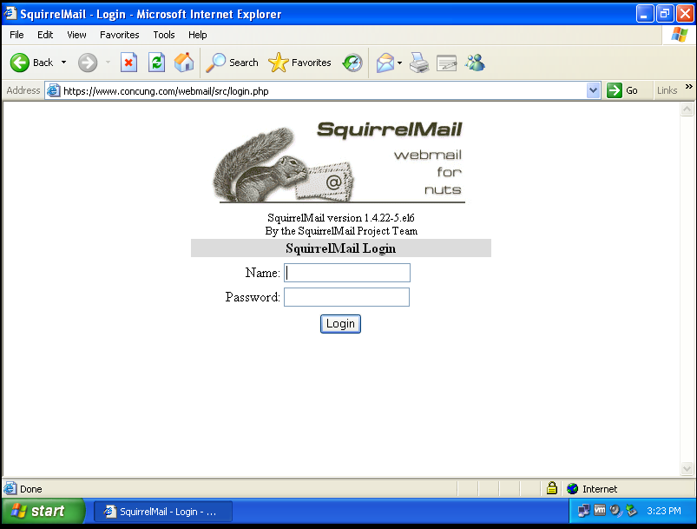
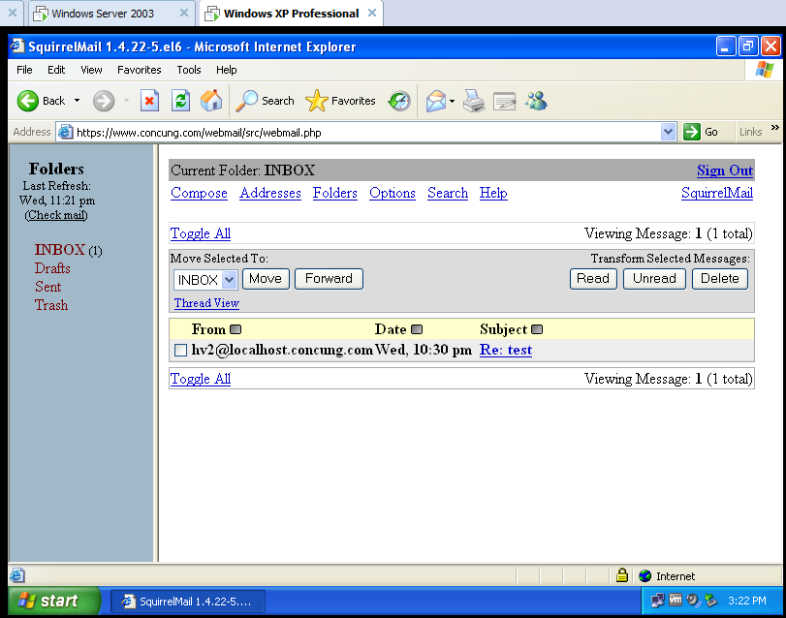
==============================THE END ==========================

